3 April 2020
Digital Image Processing Lab Manual
Accompanies the Textbook:
Remote Sensing: Principles, Interpretation, and Applications.
Floyd F. Sabins and James M. Ellis, 2020, Waveland Press, Illinois.
The Digital Image Processing Lab Manual contains twelve lab exercises:
Lab 1 Introduction to ENVI – Five Display tools
Lab 2 Landsat Multispectral Processing - Seven Display tools
Lab 3 Image Processing 1 - Five Toolbox tools
Lab 4 Image Processing 2 - Four Toolbox tools
Lab 5 Band Ratios and Principal Components
Lab 6 Georeferencing
Lab 7 DEMs and Lidar
Lab 8 IHS and Image Sharpening
Lab 9 Unsupervised Classification
Lab 10 Supervised Classification
Lab 11 Hyperspectral
Lab 12 Change Detection and Radar
The lab manual uses data in the textbook’s Remote Sensing Digital Database, along with data from other sources. Each lab exercise includes references to discussions, figures, and plates in the textbook. The labs provide step-by-step guidance using L3Harris ENVI image-processing software. Each lab handout averages 15 pages with screen captures of properly configured software menus, questions for the students to answer, and requests for student-processed files to be uploaded to the instructor.
Lab exercises 1 to 12 can be downloaded as zip files from the publisher’s website. Each lab exercise contains the following:
1) lab handout (as Adobe Acrobat .pdf and Microsoft Word .docx documents),
2) lab assignment (as Adobe Acrobat .pdf and Microsoft Word .docx documents),
3) lab data (a small folder with ancillary data – except labs 4 and 8).
Each lab exercise handout is a standalone document. The lab assignments (questions and upload requests) are printed with the topic of interest in the handout and are also sequentially compiled on the last page(s) of the handout. In addition, each lab exercise assignment is provided as a separate document to facilitate use by the students. An example of a downloaded and unzipped lab exercise 2 is shown below:
Users can add or delete sections in each lab exercise handout and assignment to accommodate their lab schedule. Users can retain the structure and concepts in each exercise while replacing the step-by-step directions designed for ENVI software with instructions specially made for their image-processing software.

Self-Taught Students
Self-taught students have the opportunity for a 30-day, free ENVI license (contingent upon U.S. laws and regulations) to complete the exercises and process other imagery in the database. Contact James Ellis via email jellis@ellis-geospatial.com to facilitate coordination with the L3Harris Academic & NGO Account Manager. Prior to launching the 30-day ENVI license, self-taught students should read Chapters 1-10 of the textbook to become familiar with remote sensing principles and technology and to learn about the many examples that are discussed in the textbook and used in the lab manual.

L3Harris ENVI Software
The lab exercises use the new ENVI “GIS-look” software, except for a couple exercises that revert back to the ENVI “Classic, 3-window” option. The new ENVI "GIS-look” software program creates ".enp" files when images are opened and processed. So in the Lab Data folders you will see .enp files with the same file names as the .tifs and .img (ENVI format with .hdr header). The new ENVI "GIS- look” program also creates multiple files when displaying GIS shapefiles. These files include ".ebb, .ed1, and .eq1" formats. In the lab exercise data folders you will see these ENVI-only files with the same file name as the many other files that are associated with one shapefile.

Compilation of Lab Manual Exercises 1 to 12
The twelve lab exercises are compiled into one 22 MB pdf named “Compilation of Lab Manual Exercises 1 to 12.” This collection of the lab exercises is available for download from the publisher’s website. Adobe Acrobat Reader DC is a free software program that will display the 181-page document. Use the “Bookmarks” tool to more easily locate and access the individual lab handouts in the 22 MB pdf document.

Answer Keys
Instructors have access to the password-protected answer keys for each lab exercise assignment at the publisher’s website. Examples of acceptable student-processed uploads (jpgs, geotiffs [.tif with .tfw], and shapefiles) are also provided for each lab exercise.

Answering Questions on the pdf Assignment Sheets
Space has been left between questions on the pdf assignment sheets so students can type in their answers (or print out the assignment sheets and manually write in the answer).
Adobe Acrobat Reader DC is a free software program that will display the assignment sheets (see below). Students can use the “Fill & Sign” tool available along the right margin of the Reader to type answers into the assignment sheets. The student aligns the typing window (with blue banner as shown below) after the question and types the answer. The student can save the pdf by adding his/her name with the Lab number to the lab assignment pdf (for example, “StudentName_Lab4”).
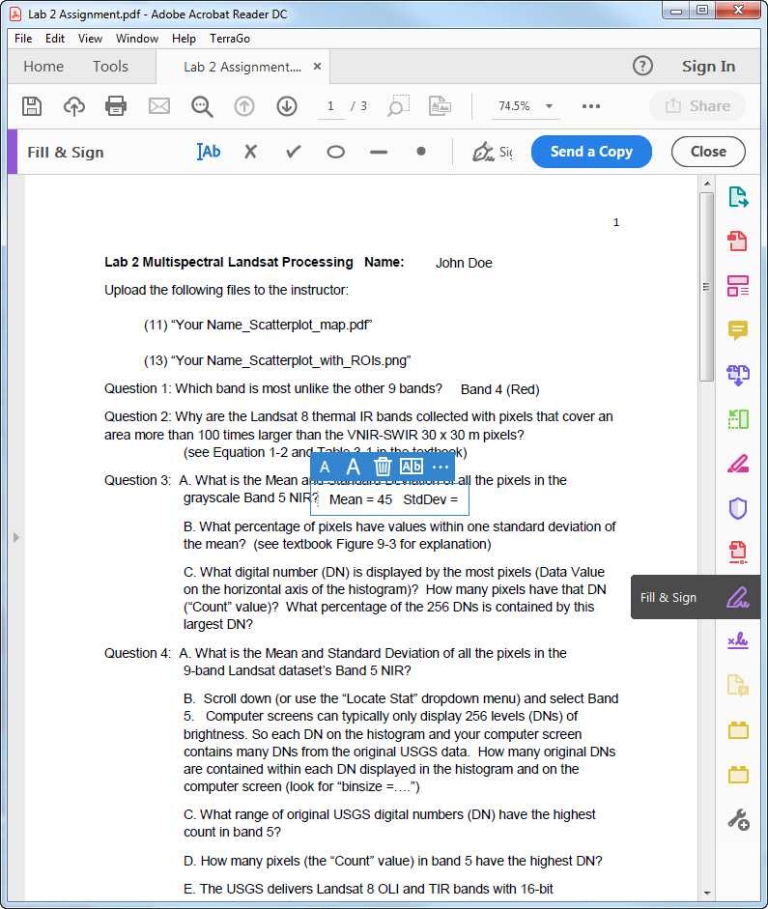
For questions or comments contact James Ellis jellis@ellis-geospatial.com

